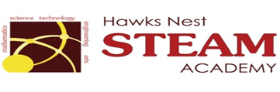School Counseling Program Newsletter
Shandrai Silva, School Counselor | March 2017

Counselor Message  Happy March! We are looking forward another great month at the Nest!  In February, the school counseling program continued with classroom guidance lessons, small group counseling and individual meetings with students. We recognized Random Acts of Kindness Day with Student Council members performing acts of kindness throughout our school. Student Council members are also serving in lower grade classrooms. We’re proud of their leadership!  This month, we are participating in a school-wide service project, Pasta for Pennies. Students are collecting money to support the Leukemia & Lymphoma Society. We are also preparing for our upcoming Career Day.  Great things are happening at the  Nest! Stay Tuned!  _________________________  How to see the school counselor  Classroom guidance classes are weekly based on grade level specials schedule. Small group counseling and individual counseling by self -referral, parent referral, teacher referral, administrator referral or counselor initiated.  Contact School Counselor at 704-866-8467or sosilva@gaston.k12.nc.us.   | Home of the Hawks    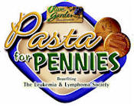  March 6- 17, 2017  Service project to raise  Money for Leukemia &  Lymphoma Society.   | Character Education  “We’re Soaring with Good Character”  ______________________________  The character trait of the month is Good Judgment. Good Judgment means to choose worthy goals; thinking through the consequences of your actions; and basing your decisions on wisdom and good sense.  ________________________________    “Intelligence plus character- that is  the goal of true education.”  Dr. Martin L. King, Jr.    